Be Creative! Tributes can contain photos, GIF's, or other media - you will see some examples shown for you to get ideas. You can always contact us at info@wsjhs.org to get guidance or help with creating your personalized and unique Tribute.
Remember these tributes will be preserved in the WSOHS Digital Museum/Website so we welcome your creativity and are here to help.
From The WSJHS Staff

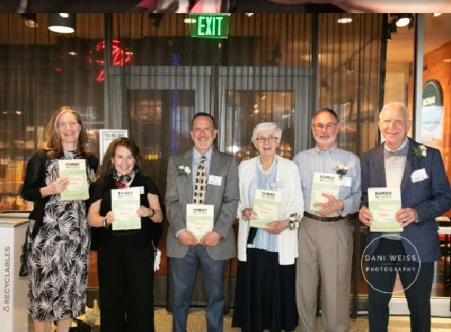
Lisa with Authors, Creators and Family at the Launch of the 2nd Edition of Family of Strangers

We truly appreciate the work you have done on behalf of the Community these last 20 years!
From WSJHS Board of Directors
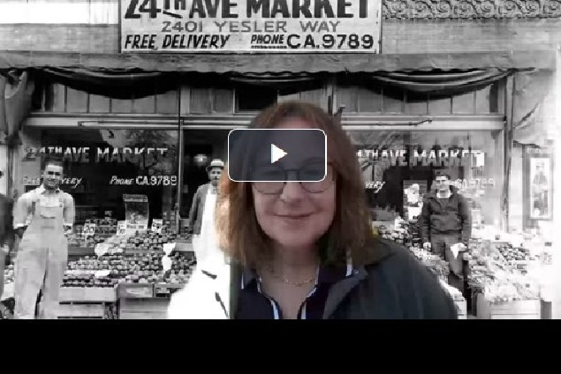
Lisa thanks everyone - the WSJHS Board, the WSJHS staff (past and present) and the Community for believing in the work of the WSJHS and for their support to Lisa for the last 20 years in her work as Executive Director. Thank you. in advance, for all the generous tributes on her behalf and supporting the WSJHS.

